**Ideation Phase Define the Problem Statements**

|  |  |
| --- | --- |
| Date | 31 October 2022 |
| Team ID | PNT2022TMID41712 |
| Project Name | AI based discourse for Banking Industry |
| Maximum Marks | 2 Marks |

**AI based discourse for Banking Industry:**

In a competitive, rapidly changing business world, one of the most well-known and significant drivers of how firms provide value to their consumers is digital transformation. One of the most significant technology transformations nowadays is widely acknowledged as artificial intelligence (AI).enablers in a large range of different sectors. Using artificial intelligence (AI) could assist businesses become more creative, adaptable, and flexible than they have ever been. Artificial intelligence (AI) is already being used to boost production and competitiveness while simultaneously Various organizations are undergoing digital transformation. Objectivity of the Study Indian banks are increasingly utilizing cutting-edge technology to cater to a younger audience. and increase their capacity for development.AI is assisting Indian banks in modernizing many aspects of their business, including accounting, sales, contracts, and cybersecurity.

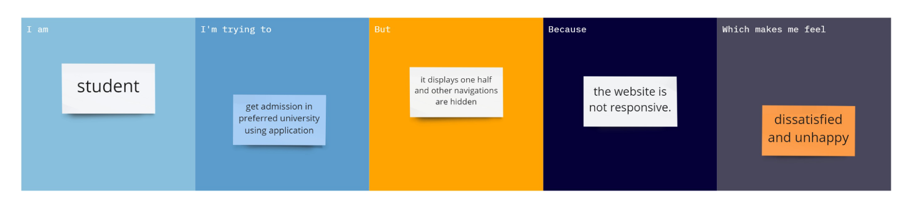

|  |  |  |  |  |  |
| --- | --- | --- | --- | --- | --- |
| **Problem**  **Statement**  **(PS)** | **I am Student** | **I am trying to** | **But** | **because** | **Which makes me**  **feel** |
| **PS-1** | Student | Get admission in preferred university using application | It display one half and other navigation are hidden | The websites is not responsive | Dissatisfied and unhappy |